Homework 6

Sandhya Mamidi(S02061097)

Java program to read JSON from a file “c:\tool\JSONExample.txt”

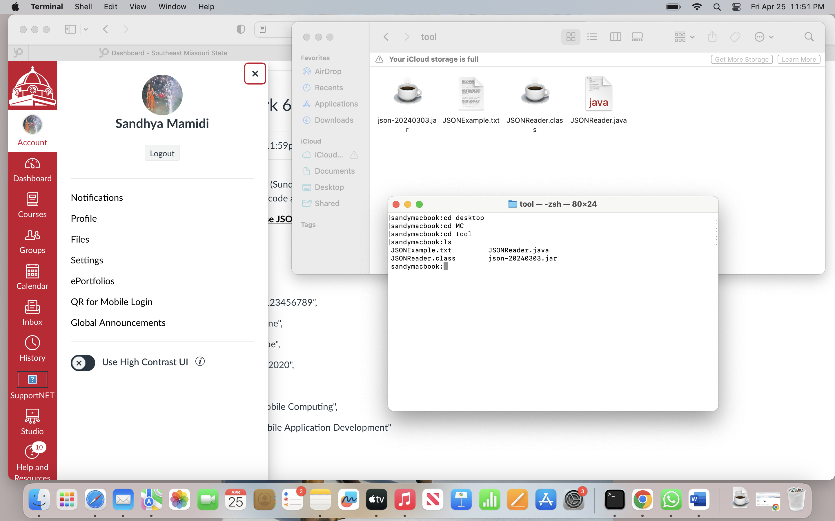

JSON text file  
  
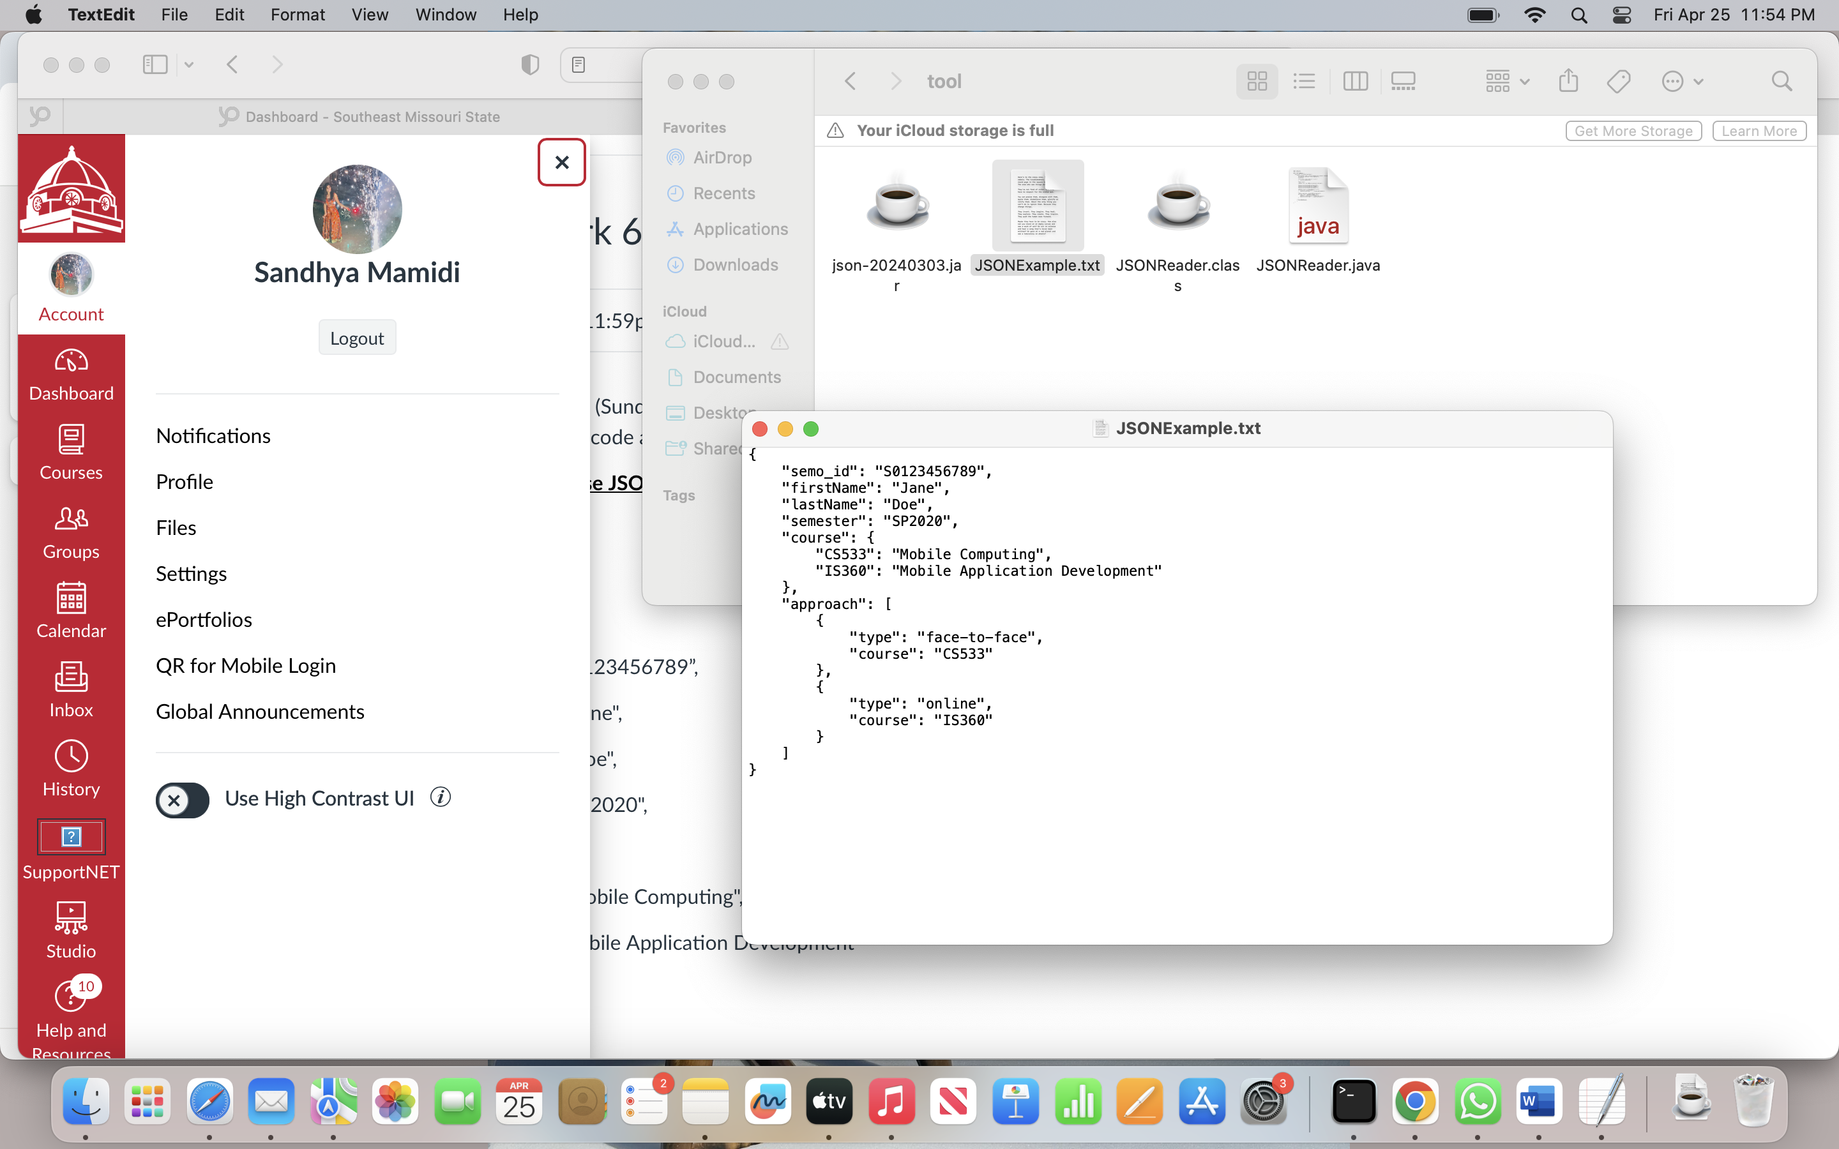

Java program in the same file  
  
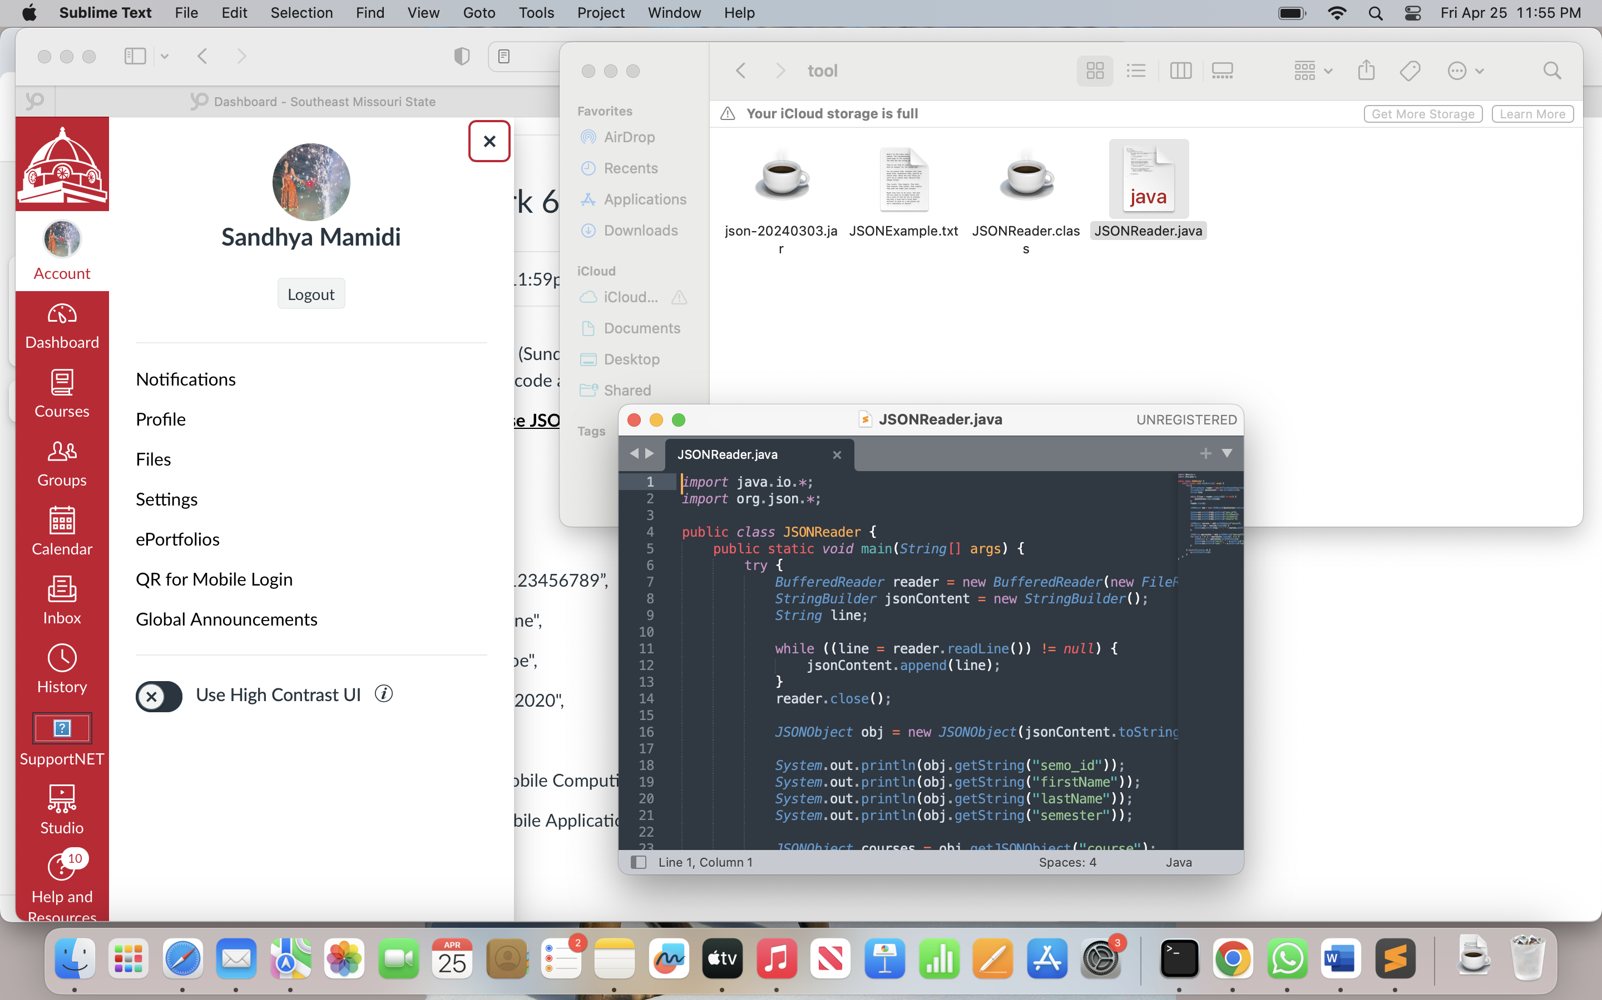

In order to support JSON to java Downloaded json.jar

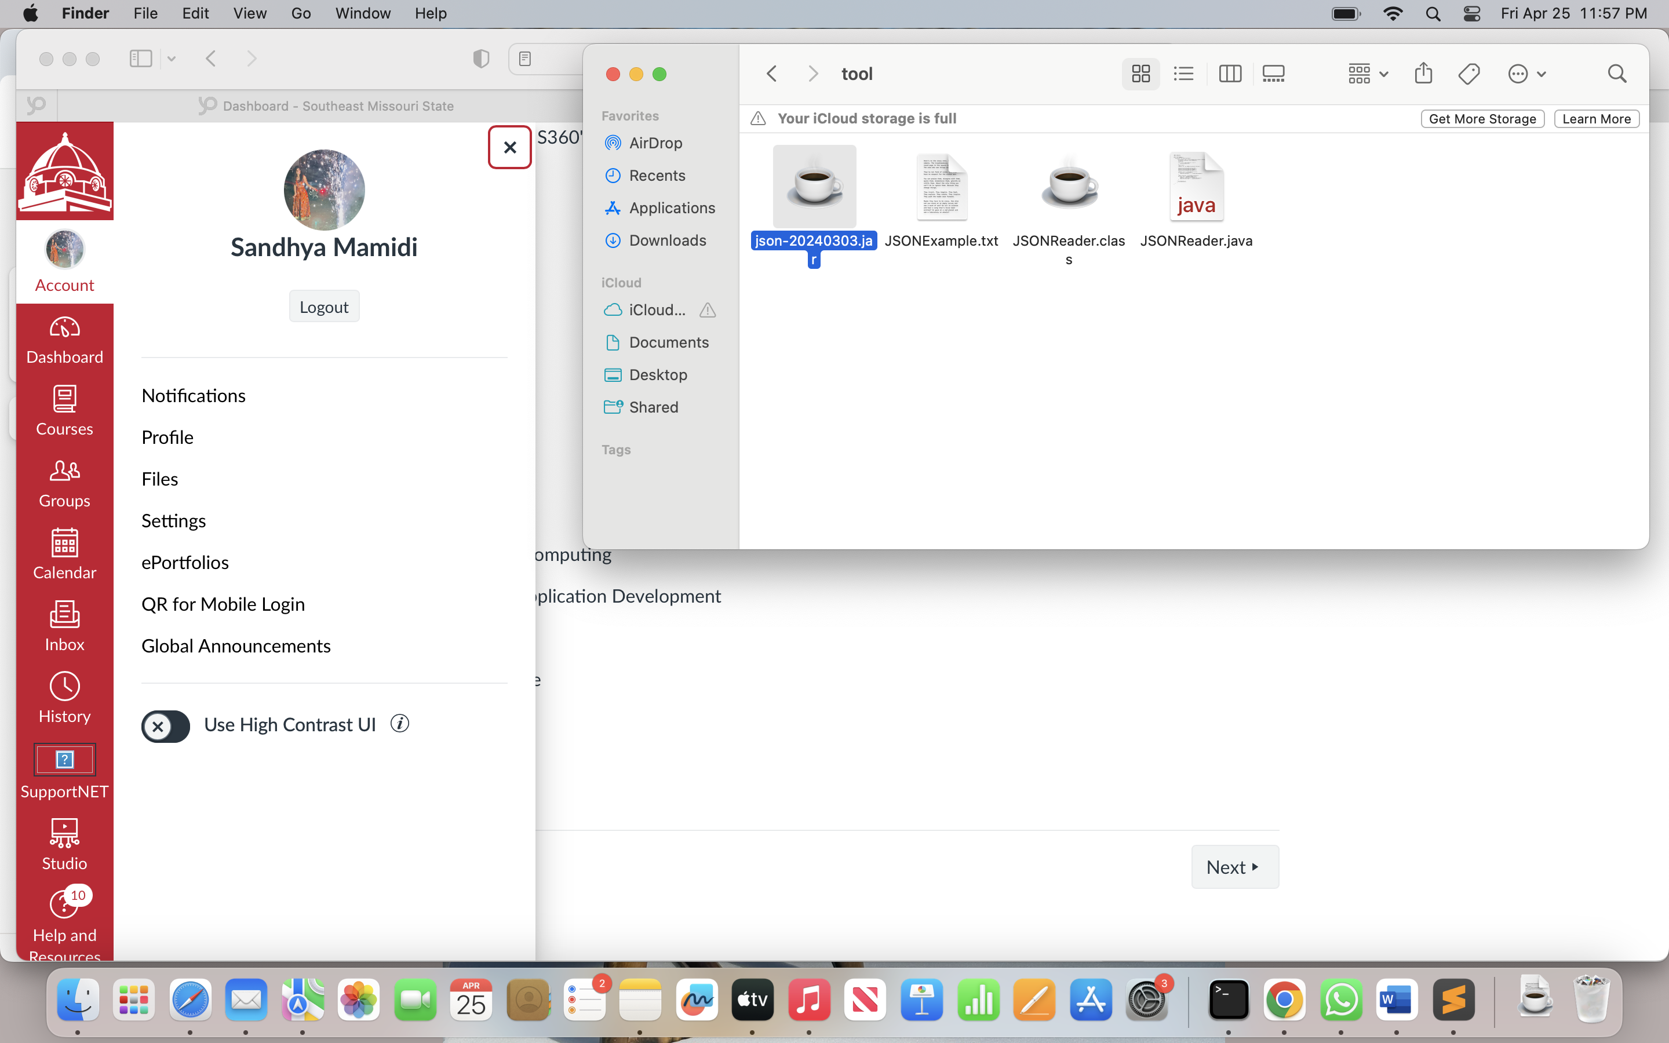

Compilation

